**Smart Door Lock System Using Keypad**

**TABLE OF CONTENTS**

1. Introduction
2. Background of Study and Motivation
3. Project Objectives
4. Literature Review
5. Methodology and Modeling
6. Introduction
7. Working Principle
8. Important Components
9. Arduino Code
10. Circuit Diagram
11. Conclusion

# INTRODUCTION

## Background of Study and Motivation

In our daily lives, safety is a major concern. Every person requires a sense of safety. Our security pattern includes an access control system for doors. Traditional locks are no longer as secure as they once were; anyone can gain access by breaking these locks. We need to create a system that will assist 24 hours a day, seven days a week. Only authorized individuals have access to restricted areas thanks to a password-based door lock system. Arduino is in charge of the entire system. A keypad can be used to enter the password. The door opens if the password matches the password entered in Arduino. This password-based bolt structure will provide clients with a more secure and low-effort locking-opening mechanism. Mechanical door locks will be replaced by electronic door locks in the future, thanks to the security door lock automation system.

## Project Objectives

The goal of this project is to research and analyze a suitable collection of components for developing a smart door lock using Arduino that provides excellent security and quick access. The following are the specific project goals:

* Familiarity with a smart door locking system based on a microcontroller.
* Using Arduino to create a simple and smart door locking system.

# LITERATURE REVIEW

There are just a few digital approaches for door security locks in the current system. This contemporary smart locking system takes the place of the classic lock and key locking method. Modern living is largely reliant on technological advancements, such as opening doors, managing the air conditioning, and regulating the curtains. People want to feel safe in their own homes, offices, and stores. The primary motivation for the development of smart locks is to meet the needs of people. Some of these systems will be discussed in this section.

## Internet of Things

The internet of things, or IoT, is a wireless link that works in a door lock. With the help of IoT-enabled applications, the user may unlock the door with his smartphone. The servo library is introduced after the application is developed by creating a string variable that contains the unique device ID for the lock. The essential concept underlying the door lock's operation is the ID supplied by the Android phone via the created app.

## Knock-Pattern Using Arduino and GSM Communication

This system, which consists of Arduino, GSM Module, Servo Motor, and other components, employs a ‘Secret Knocking Pattern' that is only known by the owner of the safe, luggage, or other property or item on which the device is mounted. For the lock to open, the knocking pattern must be used only at a certain location, which is only known by the owner. The secret pattern can only be changed after the secret knock has been unlocked. Because there is no key to be copied, this approach fully eliminates the worry of duplication.

## Keyless Entry System Based on Arduino Board with Wi-Fi Technology

A keyless entry system that focuses on the use of an Arduino circuit board, a Wi-Fi module, and the PHP programming language to provide access to a closed door. The suggested solution, which uses an Arduino Uno board and a Wi-Fi shield to unlock the door without a key, is described. The internet connection allows the system to unlock the door from any place, unlike traditional systems, which have a limited range.

## RFID Based Access Control System

A magnetic door lock is administered through an RFID reader in the suggested system, which begins the authentication and validation of the user or regulates access in short. In addition, the systems keep track of each user's access and exit records in the form of a log report for each access. To avoid unforeseen circumstances, the administrator of the central subsystem can terminate the validity of any user at any moment.

# METHODOLOGY AND MODELING

## Introduction

In this project, we implemented a Password-Based Security System Using Arduino & Keypad. As thefts are increasing day by day security is becoming a major concern nowadays. So, a digital code lock can secure our home or locker easily. It will open your door only when the right password is entered. Only authorized people are allowed access to the restricted sections due to a password-based door lock mechanism. The Arduino is responsible for the entire project's operation. The desired password can be entered using a 4×4 keypad.

In this project, we have defined the default password “123A456” in the Arduino. You can change it via coding. When we enter a password, it will match it with the password stored in the Arduino. If it is correct, then it will show ‘Access Granted, Welcome’ and then rotate the servo motor to 180 doors as the door is opened. It will then give 5 seconds time for entering via the door. Once 5 seconds is completed, the door will get locked automatically.

If the password is wrong, then it will show ‘Code Incorrect, Go Away’. The buzzer will also beep once when any key is pressed.

## Working Principle

**Process of Work:**

The purpose of this experiment is to implement a door-locking mechanism that opens or closes the lock on the door automatically with a key code. There are two work processes for this experiment which are:

**Case 1: The lock will open:**

A Keypad will input values allowing us to compare the values with the string of integer values that are set in the code. When inputting a code comprising of integer values with the help of the Keypad, if the string of integer values matches the string of integer values already fixed in the code, the keypad will send a signal to the display and the “Code Accepted” message will be shown. If the code is accepted, the Arduino will send a signal to Servo Motor. The Motor will then rotate 90° and open the lock, allowing the door to be unlocked.

**Case 2: The lock will not open:**

If the code inserted in the Keypad does not match the fixed string in the code, the Keypad will send a signal to the Display to show the “Wrong Code” message. Pressing the wrong values in the Keypad will automatically instruct the user to start again from the beginning. If the “Wrong Code” message is shown, the Servo Motor will not rotate and the lock will not open allowing the door to remain locked.

## Important Components

**Hardware:**

* Arduino UNO
* 4×3 Matrix Keypad
* PWM Powered Servo Motor
* 16×2 LCD Display

**Software:**

* Arduino IDE

### Arduino UNO:

Arduino is an open-source platform used for building electronics projects. Arduino consists of both a physical programmable circuit board (often referred to as a microcontroller) and a piece of software, or IDE (Integrated Development Environment) that runs on your computer, used to write and upload computer code to the physical board. The Arduino platform has become quite popular with people just starting with electronics, and for good reason. Unlike most previous programmable circuit boards, the Arduino does not need a separate piece of hardware (called a programmer) to load new code onto the board -- you can simply use a USB cable. Additionally, the Arduino IDE uses a simplified version of C++, making it easier to learn to program. Finally, Arduino provides a standard form factor that breaks out the functions of the micro-controller into a more accessible package.

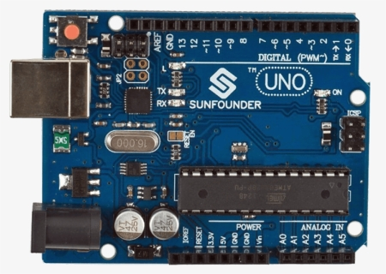

### 4×4 Matrix Keypad:

This 4x4 matrix keypad has 12 built-in pushbutton contacts connected to row and column lines. A microcontroller can scan these lines for a button-pressed state. In the keypad library, the Propeller sets all the column lines to input and all the row lines to input. Then, it picks a row and sets it high. After that, it checks the column lines one at a time. If the column connection stays low, the button on the row has not been pressed. If it goes high, the microcontroller knows which row (the one it set high), and which column, (the one that was detected high when checked).

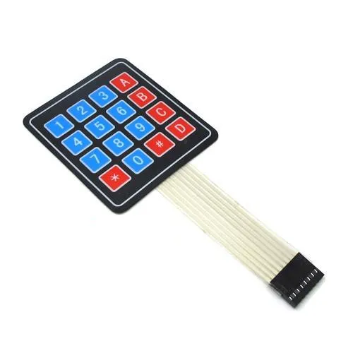

### 16×2 Alphanumeric Display:

An LCD (Liquid Crystal Display) screen is an electronic display module and has a wide range of applications. A 16x2 LCD is a very basic module and is very commonly used in various devices and circuits. A 16x2 LCD means it can display 16 characters per line and there are 2 such lines. In this LCD each character is displayed in a 5x7 pixel matrix. The 16 x 2 intelligent alphanumeric dot matrix display is capable of displaying 224 different characters and symbols. This LCD has two registers, namely, Command and Data.

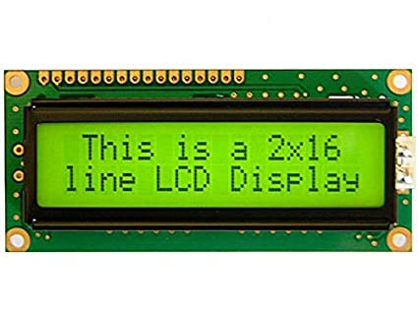

### PWM Powered Servo Motor:

This A servo motor is a rotational or translational motor that receives power from a servo amplifier and is used to impart torque or force to a mechanical device like an actuator or a brake. Servo motors provide exact angular position, acceleration, and velocity control. A closed-loop control system is used with this type of motor. A closed-loop control system takes the current output into account and adjusts it to the desired state. The output of the motor drives the control action in these systems. The velocity and final position of the shaft is controlled by a positive feedback mechanism. In these motors, there are two forms of current flow: AC and DC. AC servo motors are more typically found in heavy industrial machines because they can sustain higher current surges. DC Servo Motors from ISL are best suited for compact applications and provide great control and feedback. The frequency of the applied voltage and the number of magnetic poles affect the speed of a servo motor.



## Arduino Code:

#include <Wire.h>

#include <LiquidCrystal_I2C.h>

#include <Keypad.h>

#define Password_Length 8

#include <Servo.h>

Servo myservo;

char Data[Password_Length];

char Master[Password_Length] = "123A456";

byte data_count = 0, master_count = 0;

bool Pass_is_good;

char customKey;

const byte ROWS = 4;

const byte COLS = 4;

char hexaKeys[ROWS][COLS] = {

{'1', '2', '3', 'A'},

{'4', '5', '6', 'B'},

{'7', '8', '9', 'C'},

{'*', '0', '#', 'D'}

};

byte rowPins[ROWS] = {9, 8, 7, 6};

byte colPins[COLS] = {5, 4, 3, 2};

Keypad customKeypad = Keypad(makeKeymap(hexaKeys), rowPins, colPins, ROWS, COLS);

LiquidCrystal_I2C lcd(0x27,16,2); // set the LCD address to 0x27 for a 16 chars and 2 line display

void setup(){

lcd.init();

lcd.backlight();

myservo.attach(11);

myservo.write(0);

Serial.begin(9600);

}

void loop(){

lcd.setCursor(0,0);

lcd.print("Enter Password:");

customKey = customKeypad.getKey();

if (customKey){

Data[data_count] = customKey;

lcd.setCursor(data_count,1);

lcd.print(Data[data_count]);

data_count++;

}

if(data_count == Password_Length-1){

lcd.clear();

if(!strcmp(Data, Master)){

lcd.print("Correct");

myservo.write(90);

delay(5000);

myservo.write(0);

delay(50);

}

else{

lcd.print("Incorrect");

delay(1000);

}

lcd.clear();

clearData();

}

}

void clearData(){

while(data_count !=0){

Data[data_count--] = 0;

}

return;

}

## CIRCUIT DIAGRAM:

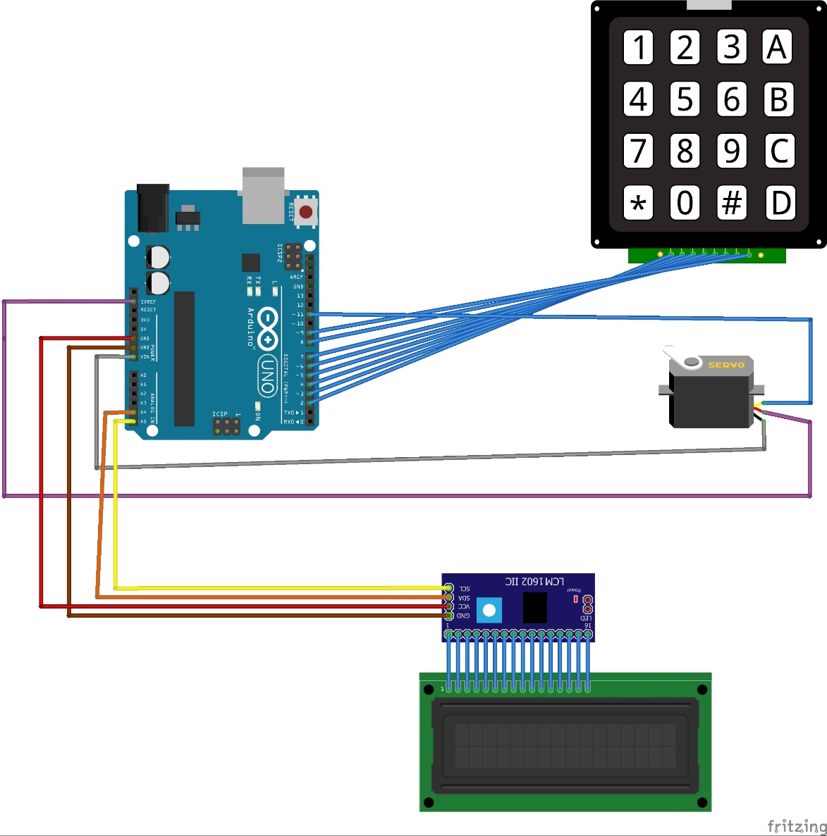

# CONCLUSION

Thus “Smart Door Locking System using Arduino” is a modern successor of the conventional door locking system. The conclusion of the discussion of smart Lock using Arduino is the innovation created from the lock system with no more direct contact between the user and the lock. This system is very cost-effective and easy to install. In conclusion, it was discovered that the project performed according to specification and can be implemented. The use of the Arduino UNO microcontroller in this project allows for design simplicity, hence, the project can be achieved in lesser time compared to other techniques previously employed. This work proposes a secure locking/unlocking system based on a keypad and Arduino. Adding password to the Arduino side increase the system security. The system also has a feature for locking itself after some delayed time. This system could be used to prevent houses, companies, institutions from stealing or losing the ordinary key.